FEBRUARY 2022 CHIRP NOT FINAL w etc.
February Brings Birds to Reserva Las Gralarias (RLG)
By Jane A. Lyons
I started taking Spanish lessons when I was in the third grade at Casis Elementary School in Austin, Texas. This was thanks to Señor Millán, a graduate student from Colombia pursuing his PhD at the University of Texas and who gave us a 30-minute class in conversational Spanish before actual school classes began. From then on, my father decided that I ‘spoke’ Spanish, and I continued to take all available Spanish classes and eventually earned a BA, MA and ABD in Spanish and French (before switching to Zoology). My father’s office was next door to a Mexican food restaurant called El Toro and we ate Mexican food 2-3 times per week. We travelled to Mexico a lot, and from then on, I did in fact speak Spanish quite well and eventually began to help arrange and lead tours to Mexico and beyond. I even assisted in two legal matters concerning car accidents (not mine fortunately) involving US citizens in Mexico and which is when I learned about the difference between English common law and the Napoleonic Code as applied in Latin America. This was long before the internet existed and even before fax machines, and most folks in Latin America did not have much access to telephones and even less to postal services. So, it was a real challenge to arrange anything in remote sites.
Why am I reminiscing so much?? My Spanish language classes and travel had taught me that the word ‘tapaculo’ comes from the verb ‘tapar’ meaning to cover and the noun ‘culo’ which is a colloquial term for ‘rear-end’, so that the name ‘Tapaculo’ actually meant something like “cover your rear-end”, so I was curious and interested to see this group of neotropical bird species. Tapaculos are in the family Rhinocryptidae that contains 12 genera and 65 species. They are found only in the neotropics and range only from Costa Rica south to southern Chile and Argentina. They are highly diverse throughout the Andes and are also found in Amazonia. Even with much taxonomic work still to be done, they are considered most closely allied to antthrushes, ground-antbirds and gnateaters with some traits similar to a few Australian bird families. Among their most striking morphological features are a short, cocked tail, large feet and strong claws, a fairly complex syrinx, sternum and associated muscles which are responsible for their very loud calls. In addition, tapaculos have a plate-like covering over the nostrils which explains their family name Rhinocryptidae which means “covered nose”. And, once you have watched a few tapaculos you will note how they generally lean forward, exposing even more their uncovered rump. Their short roundish wings result in an inability to fly far, but their ability to run fast, their highly camouflaged plumage and prominent upwards tail no doubt all form part of their protective ‘gear’ to evade overhead predators.
Birding has taken many of us adventurers on wonderful tours throughout Mexico, Central America and South America. There are hundreds of fascinating bird species in the neotropics, but I was always especially curious to actually see the birds with the covered nostrils and the uncovered rump. However, my first tapaculo was not until 1991 in the Ecuadorian Amazon. One perfect day I watched a stunning Rusty-belted Tapaculo (Liosceles thoracicus) as he performed his rapid ‘moonwalk’ backwards on the ground while emitting a loud long fast series of hoots, all of which was rather bizarre to experience. Then the following year I watched a nice ‘mouse-like zoom around a tree’ performance of the equally bizarre although not as fancy Slaty Bristlefront (Merulaxis ater) near the Hotel do Ypé in southeastern Brazil. It is a delight and honor to see these difficult-to-find species, and now to have three species of tapaculo encircling my house at RLG is rather hard to believe.
For birders, tapaculos are divided into the fancy ones and the plain ones. At RLG we have two plain species, the Nariño Tapaculo (Scytalopus vicinior) and the Spillman’s Tapaculo (Scytalopus spillmanni), both small and dark blackish gray with shades of brown on the flanks and rump. Once considered just one species, a landmark study published in 1997 by Niels Krabbe and based along the roads and sites near RLG’s upper properties described these two as different species, with the Nariño being the lower elevation species and the Spillman’s the upper elevation species, although at RLG and even behind my house they overlap continually. Being close to impossible to actually see and decidedly impossible to photograph, each has a very distinct call which formed the basis of the splitting of the single species into two species and allows birders to know which invisible tapaculo is nearby. According to experts, “The systematics of the genus Scytalopus are among the most problematic within the entire avian class.” And in fact, since 1970, 27 new species of Scytalopus have been described. (P.750, Volume 8, HBW).
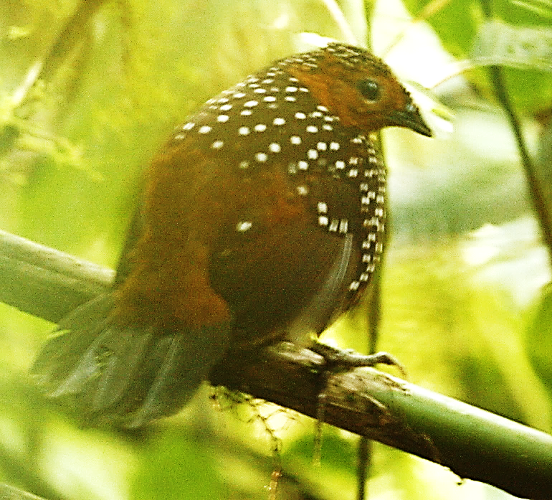
At RLG our first recorded tapaculo was this Ocellated Tapaculo in 2009. Its bright white spots and large size make it easier to see than most other forest tapaculos. Photo by Luke Seitz
Fortunately, the larger and fancier tapaculos are usually more visible. And very fortunately we have quite possibly the fanciest of all tapaculos at RLG. We have heard and seen a good number of the beautiful Ocellated Tapaculo (Acropternis orthonyx) in all areas of our upper properties. But what a shock on 22 January 2022 to hear right outside the main kitchen at RLG two individuals of this tapaculo – one calling very loudly and repeatedly and a second one responding with a soft multi-syllabic almost ‘gurgly’ call which sounded very much like possibly a juvenile bird. At 7 am I was alone inside the kitchen and knew to not move closer to try to see them but was able to record them very well on my cellphone during over a minute. They finally tired of calling and vanished.
Note its pointed bill with nostril shield Photos by Milton Delgado 21 April 2021
Questions remain as to what exactly are the functions of their exceeding long hind claws and the nostril covering – perhaps the long claws are also part of their weaponry or may aid in food-gathering, and the nostril cover may keep ground dust and particles out of their nostrils.
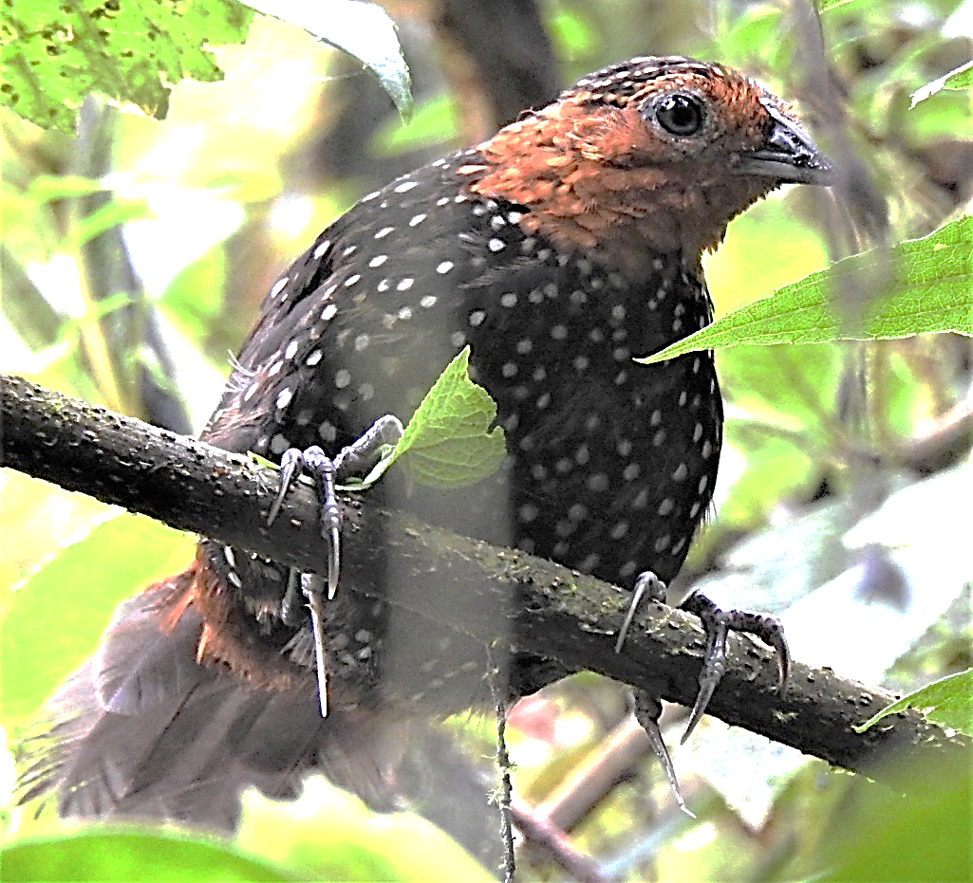
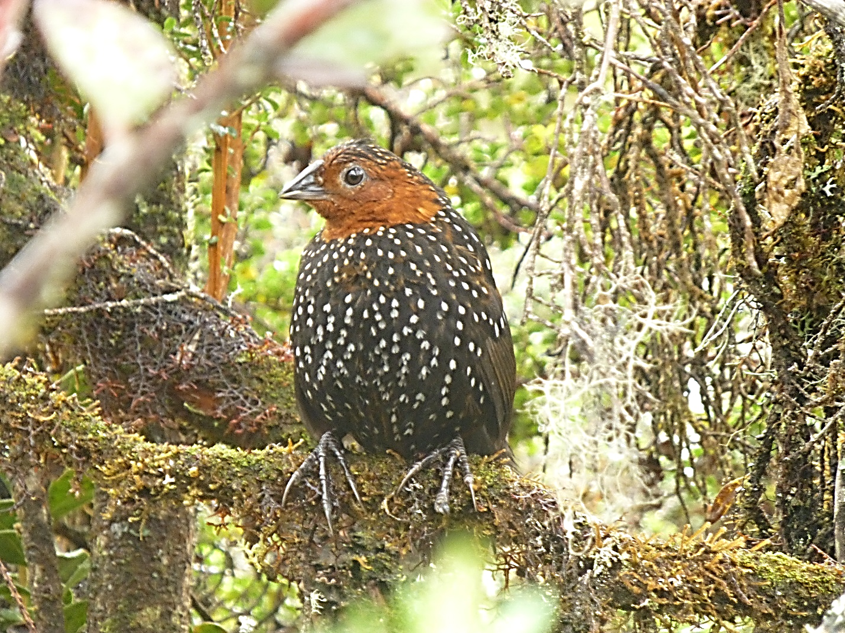The stunning Ocellated Tapaculo, with big feet and claws, covered nostrils and white-spotted body sitting among the dense moss-covered tree branches of the cloud forest. Photo by Mauricio Ruano
Normally seen on or near the ground they will fly/clamber up into trees. Note its big feet.
Photo by Marcelo Quipo, 22 January 2019
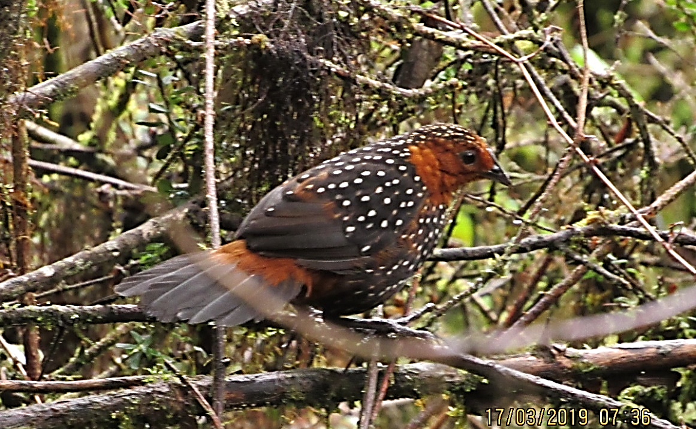
An Ocellated Tapaculo with its typical leaning-forward position, showing its tail spreading to cover its rump. As it continues to lean more forward, the tail will be held higher, and the rump will become uncovered. Photo by Mauricio Ruano.

Beyond our fancy tapaculos, additional recently returning birds at RLG have included Crested Quetzal and Lesser Violet-ear Hummingbird, two migratory species that arrived right on time during the first ten days of February.
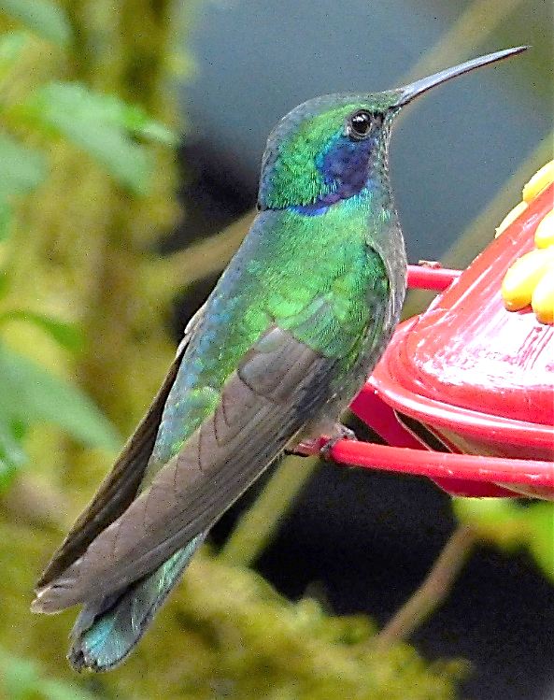
Lesser Violetear, a migrant hummer that shows up at RLG every February for its nesting season. Photo by Jane A. Lyons
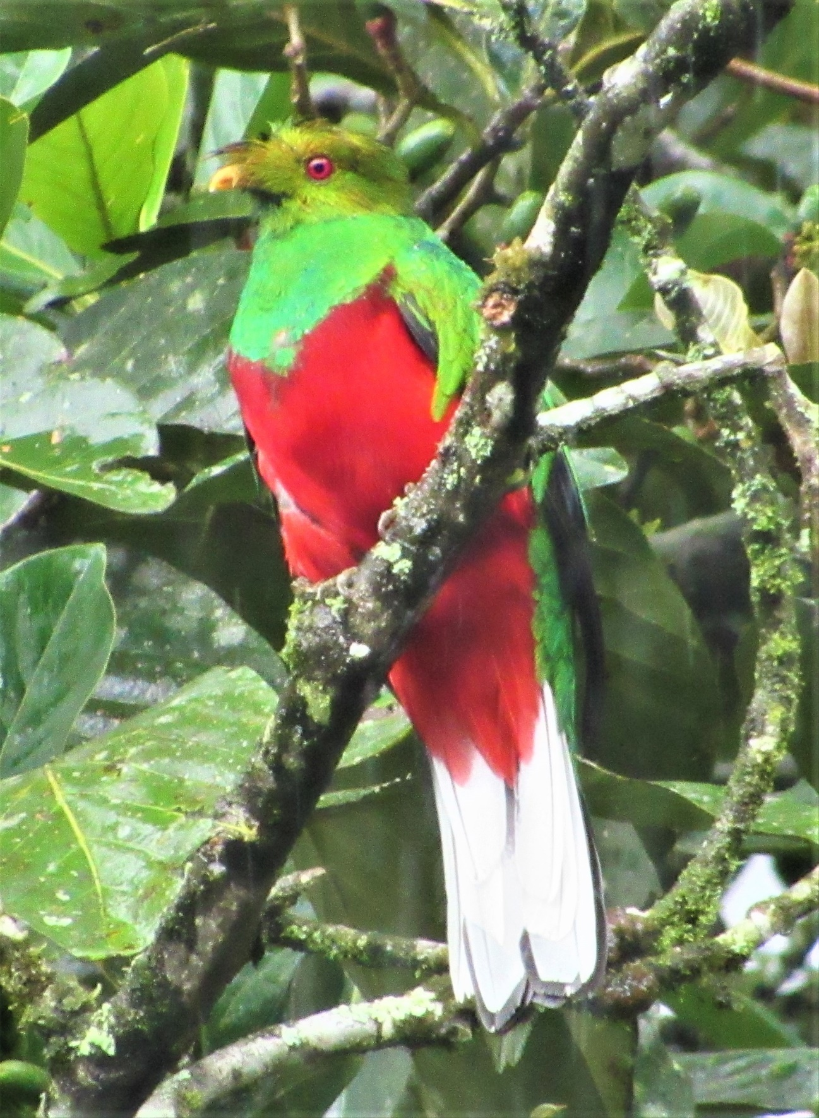
The beautiful Crested Quetzal, that also returns in February and begins to sing its very loud two-note song. Photo by Mauricio Ruano
Also, on 8 February a returning very vocal White-faced Nunbird appeared, as always, along Nunbird Ridge Trail above the Santa Rosa River and then, as always, crossed over to the area behind my house and onward along Sr. Tim’s Trail, calling along the way. He likes to repeatedly broadcast his loud call of a single note (but of variable tones) from the high ridges in order to proclaim his territory and attract a female. These birds seem to feed primarily on lizards and other reptiles. This same male (based on behavior) has been at RLG since 2004 when we watched it with the construction workers behind my house.
. 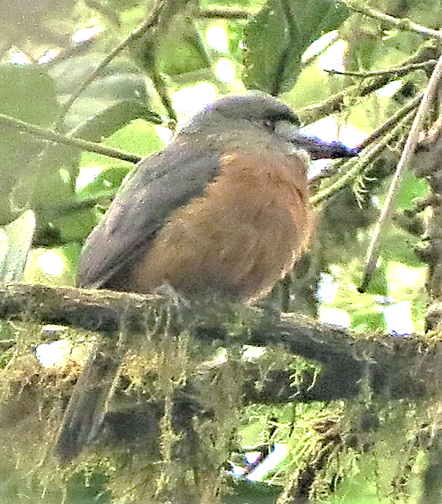 White-faced Nunbird Photo by Roy Averill-Murray

Black-chinned Mountain-Tanagers back at our banana feeders. Photo by Jane A. Lyons
Other returning birds for which February seems to be the beginning of spring include Black-chinned Mountain-Tanager back at our banana feeders, and on several occasions a pair of Swallow-tailed Kite collecting sticks from a high dead branch of an alder tree. Also of interest, we still have our Broad-winged Hawks, two individuals heard on 4 February along the road, which makes me think they may overwinter here, and also a Rufous-breasted Antthrush that flew into the dog pen on 10 February (it escaped unharmed).
By March most of these springtime birds will be tending nests, feeding young and taking advantage of our warmer springtime rains as well as the abundant insect population and the many ripening fruits that the rains bring forth.

Well-vaccinated and masked birders visited RLG throughout January and February and delighted in our ever-vocal Yellow-breasted Antpitta (Grallaria flavotincta) near the guest house. Photos below by Milton Delgado

References
del Hoyo, J., Elliott, A. & Christie, D. eds. 2003. Handbook of Birds of the World. Vol. 8. Broadbills to Tapaculos. Lynx Edicions. Barcelona.
Niels K. Krabbe and Schulenberg, T.S. 1997. Species Limits and Natural History of Scytalopus Tapaculos (Rhinocryptidae), with Descriptions of the Ecuadorian Taxa including Three New Species. Ornithological Monographs 48(48):46-88. DOI: 10.2307/40157527.

There are many specied of tapaculo that I would love to see some day. Let’s hope!
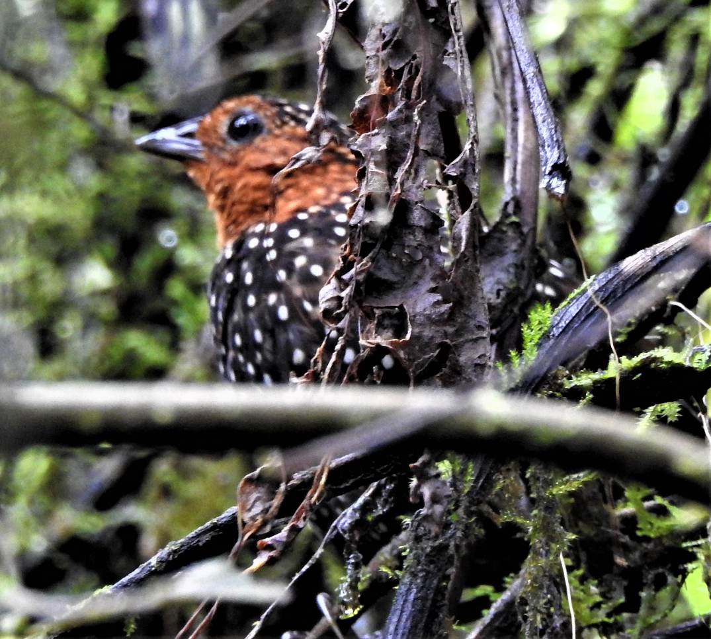
The Ocellated Tapaculo is normally found hidden in dense tangles of vegetation.
MR
And very long toenails. The back toenail is ?? long and no one seems to know for certain what special purpose it may serve. MD
The fancy tapaculo at RLG is the Ocellated Tapaculo, fairly abundant and widespread, even calling heartily at our kitchen on ??. But, again, easier heard than seen. coaxed into moving out into an area where it is visible and Being a larger tapaculo it can be with bright white spots can in fact be seen.

There are many specied of tapaculo that I would love to see some day. Let’s hope!
Birding has taken many of us adventurers on wonderful tours throughout Mexico, Central America and South America. There are hundreds of fascinating bird species in the neotropics, but I was always especially curious to actually see the birds with the covered nostrils and the uncovered rump. However, my first tapaculo was not until 1991 in the Ecuadorian Amazon. One perfect day I watched a stunning Rusty-belted Tapaculo (Liosceles thoracicus) as he performed his rapid ‘moonwalk’ backwards on the ground while emitting a loud long fast series of hoots, all of which was rather bizarre to experience. Then the following year I watched a nice ‘mouse-like zoom around a tree’ performance of the equally bizarre although not as fancy, Slaty Bristlefront () near the Hotel do Ypé in southeastern Brazil. It is a delight and honor to see these difficult-to-find species, and now to have three species of tapaculo encircling my house at RLG is rather hard to believe.

For birders, tapaculos are divided into the fancy ones and the plain ones. At RLG we have two plain ones, the Nariño Tapaculo (Scytalopus vicinior) and the Spillman’s Tapaculo (Scytalopus spillmanni), both small and dark blackish gray with dark rufous thighs and rump. Once considered just one species, a landmark study published in ??by Niesl Krabbe and based along the roads and sites near RLG’s upper properties described these two as different species, with the Nariño being the lower elevation species and the Spillman’s the upper elevation species, although at RLG and even behind my house they overlap continually. Being close to impossible to actually see and decidedly impossible to photograph, each has a very distinct call which formed the basis of the splitting of the single species into two species and allows one to know which invisible tapaculo is nearby.
Fortunately, the larger and fancier tapaculos are easier to see. And very fortunately we have quite possibly the fanciest of all in multiple areas of RLG. We have heard and seen a good number of the beautiful Ocellated Tapaculo (Acropternis orthonyx) on all areas of our upper properties. But what a shock on 22 January to hear right outside the main kitchen at RLG two individuals of this tapaculo– one calling very loudly and a second one responding with a soft multi-syllabic call which sounded very much like possibly a juvenile bird. Fortunately, at 7am I was alone inside the kitchen and knew to not move to try to see them so was able to record them on my cellphone during a fairly long time. They finally tired of calling and vanished.

Our first recorded tapaculo was this Ocellated Tapaculo in 2009. Its bright white spots and large size make it easier to spot than most other forest tapaculos. Photo by Luke Seitz
The fancy tapaculo at RLG is the Ocellated Tapaculo, fairly abundant and widespread, even calling heartily at our kitchen on ??. But, again, easier heard than seen. coaxed into moving out into an area where it is visible and Being a larger tapaculo it can be with bright white spots can in fact be seen.

